Digital Tech Assignment
Problem:
The problem identified is that there aren’t enough environmental awareness and action being taken towards marine life considering the amount of pollution and overfishing that affects them. According to Conservation International, 12 million metric tons of plastic is dumped in the ocean every year which show the lack of concern for marine life.
Goals:
- Spread awareness for sea life
- Show environmental changes
- Availability for a large range of players
- Have engaging gameplay
- Show how quickly this pollution is affecting marine life and that more action needs to be taken.

Stakeholders:
- Educators – Include easy to understand explanations
- Students – Have engaging and fun experience
- People unaware of this issue – Include as much information as possible about this topic in both
User Stories
- As a year 10 marine biology student, I would like to learn more about the impacts and effects towards marine life
- As a marine biologist, I would like for this problem to be understood by more people with accurate information.
- As an educator, I want this to be entertaining and engaging for my students
- As a user requiring visual accessibility, I want easy to read fonts, understandable symbols, non-excessive visual effects, a high contrast option and a narrator.
- As a user who struggles games, I want a difficulty slider to allow me to keep playing and learning the game without struggle
- As a user who doesn’t speak English, I want multiple language choices so I can read and play the game.

Step 2
Algorithm
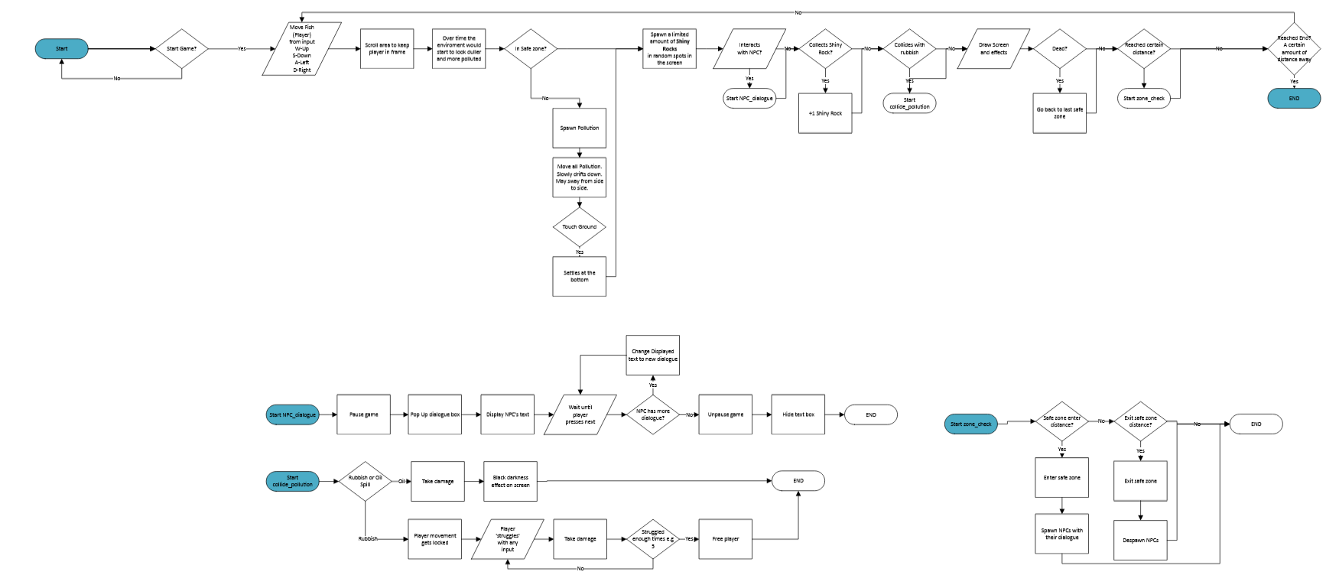

UI
4
3
2
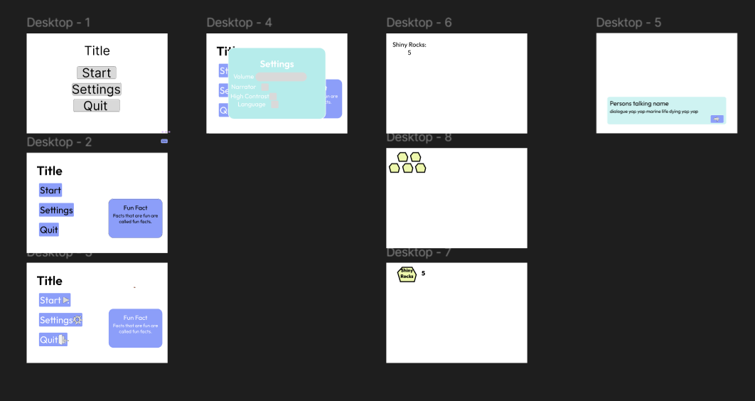
1
Chosen Options
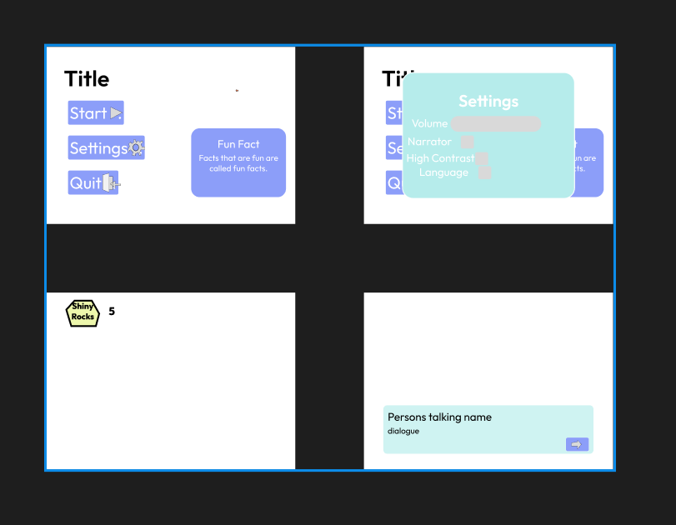
4
3
2
1
In 1, the main menu, it went through 3 iterations. In the first iteration, it was a simple centred main menu which was moved to the left side in the second iteration. It was still a simple and intuitive menu and it allowed for the fun facts box which would be useful to explain and tell more information about the topic even in the main menu. In the 3rd and last iteration, symbols were added for easier navigation and to help people who don’t know English as well.
In 2, it shows the settings menu which only one iteration was made. It was simple just showing a few settings and accessibility options including volume, narrator, high contrast and a language option. This design was simple enough and intuitive in which what each thing would mean. Adding symbols to the settings would improve this.
In 3, it shows a simple UI for in game displaying the number of shiny rocks you have collected. The one with the image of the rock with the text inside saying ‘Shiny Rock’ gave both text and symbol-based representation and just had a number beside it.
In 4, it’s a UI box which only had one iteration, just being a simple title for the person talking and what they say underneath. In the bottom right of the box, there is a next button indicated by an arrow giving a universal sign that it would be the next button.

Evaluation
Changed player, background, robot sprite and floor colour
This was done to fit the ocean environment and theme
Added up down left and right inputs and movement
This was done to allow the fish to swim up and down without jumping. This also meant that the player could adjust its speed to make It more interesting.
Made Rubbish spawn at the top
This rubbish was made to fall down to change the gameplay and make it so the player moving and down can get hit
Added Shiny Rocks
It’s a collectable that makes it so the player may have to go to in different movement or areas to collect it.
Added Tutorial
This guides the player on what keys they have to press and to avoid the trash and collect the shiny rocks

This game shows how the trash can hurt the fish. It has created engaging gameplay. The information/fun facts were not implemented at this stage of the game hindering the amount of information that can be told to the player. The game loop works and includes a tutorial so the player knows what to do. The code was effectively implemented using loops for things like creating the tutorial text.

Bibliography
https://www.condorferries.co.uk/marine-ocean-pollution-statistics-facts

